Request for Qualifications 25-01– Construction Manager at Risk

The Pinetop Fire District (the “PFD” or the “District”) is seeking a qualified Construction Manager at Risk (CM@Risk) to provide design phase assistance and complete construction services as the CM@Risk for the District’s construction of joint located facilities to include Fire Station 10, Wildland Response Station, and Fleet Facility***.***

1. **Fire Station No. 10/Administrative Facility**

* Location: 234 White Mountain Boulevard in Pinetop, Arizona
* Proposed Structure: a two-story, 3-bay, 17,000-20000 square foot fire station
* Proposed Features:
  + Apparatus Bays: Three (3) drive-thru apparatus bays
  + Living Quarters: Eight (8) Fire Fighter dorms, two (2) Captain’s offices
  + Common Areas: Kitchen, dining room, dayroom, fitness area
  + Administrative Offices: Offices and the associated operations-based functions for a typical neighborhood fire station.
  + Training & Community Space: A Fire/EMS Training/Community Room
* Estimated Budget: $11.7 Million for all three facilities
* Tentative Construction Schedule: July 2025 through March 2026

1. **The Wildland Response Station**

* Location: 234 White Mountain Boulevard in Pinetop, Arizona
* Proposed Structure: A two-story, 4-bay, 8000 square foot fire station
* Proposed Features:
  + Apparatus Bays: Four (4) back-in apparatus bays
  + Living Quarters: Twelve (12) firefighter dorms, two (2) supervisor offices
  + Common Areas: Kitchen, dining room, dayroom
  + Administrative Offices: Shared offices and associated wildland operations-based functions
* Estimated Budget: $11.7 Million for all three facilities
* Tentative Construction Schedule: July 2025 through March 2026

1. **The Fleet Facility**

* Location: 234 White Mountain Boulevard in Pinetop, Arizona
* Proposed Structure: A single-story, three (3) bay, 5000-6000 square foot fleet repair facility
* Proposed Features:
  + Building Type: Metal structure and contemporary construction materials
  + Functional Areas: Three (3) repair bays, offices and a break room, typically seen in a repair facility
* Estimated Budget: $11.7 Million for all three facilities
* Tentative Construction Schedule: July 2025 through March 2026

The desire is to build all three facilities and site development, but should the budget exceed current funding the fleet facility may be phased and not a part of this contract. The intent of the PFD is to enter into a contract to complete this project utilizing the CM@Risk as defined in A.R.S. §§ 34-101 to 34-601 *et seq*. The District anticipates completing construction by ____March 2026_______________________.

PFD has selected Perlman Architects of Arizona to provide conceptual design, programming and design services and construction administration. An Architectural contract has been executed.

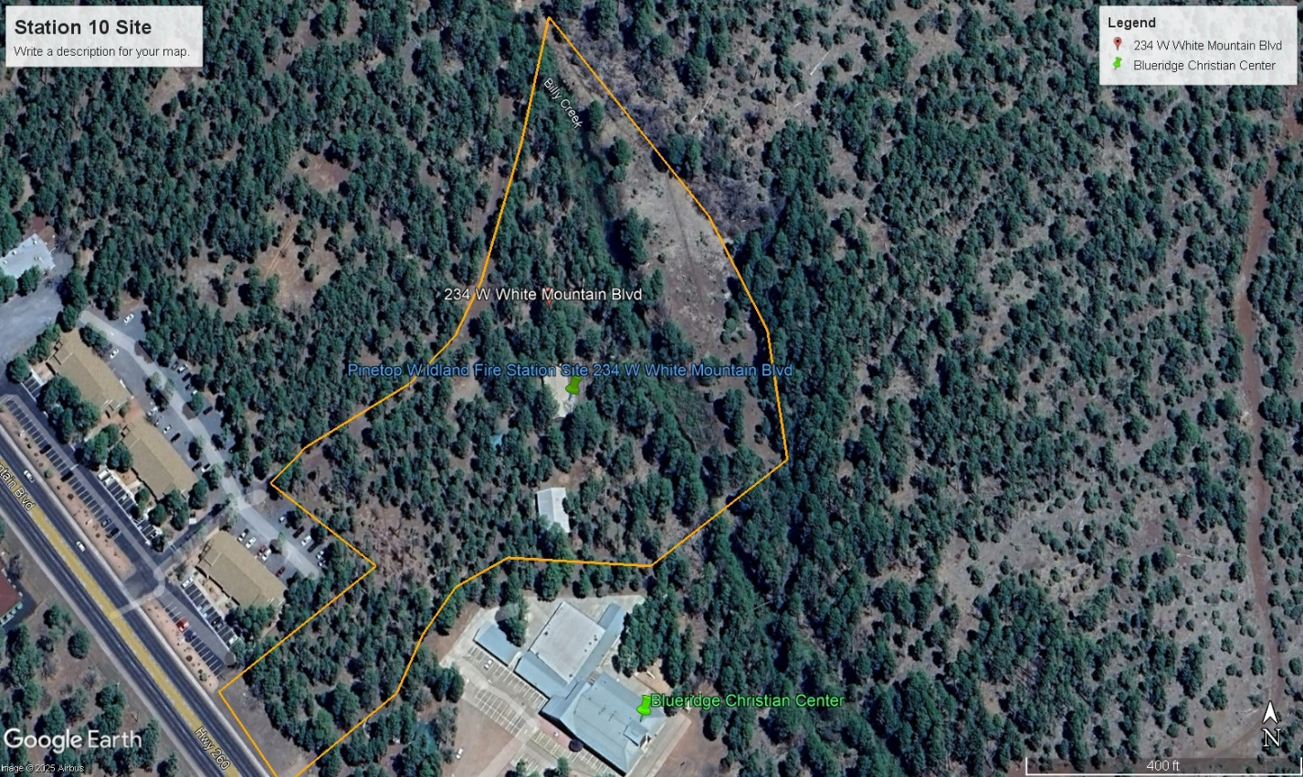

Aerial View of Site Location

# Section I - Scope

It is anticipated that the CM@Risk will participate in the design phase and the construction phase of this project.

## Design phase and pre-construction services by the CM@Risk may include, but not be limited to the following:

* Provide detailed cost estimating and knowledge of marketplace conditions;
* Provide project planning and scheduling for both design and construction phases;
* Provide for construction phasing and scheduling;
* Provide alternative systems evaluation and constructability studies;
* Advise the District of ways to gain efficiencies in project delivery and reduce overall delivery time;
* Provide long-lead procurement studies and initiate procurement of long-lead items;
* Participate in partnering sessions with the project team;
* Participate in regular scheduled project coordination meetings;
* Participate in constructability reviews at various levels of design;
* Provide sub-contractor budget and bid packages for review to project team;
* Concur with plans and specifications prior to construction; and
* Submittal of a Guaranteed Maximum Price (GMP) for District review and negotiation.
* Develop creative construction practices/ideas to ensure maximizing completion of the entire project with available funding.

## Construction phase services by the CM@Risk may include, but not be limited to the following:

* Serve as the general contractor during construction;
* Coordinate with various utilities;
* Arrange for procurement of materials and equipment;
* Schedule and manage site operations;
* Bond and insure the construction;
* Comply with all federal, state and local permitting requirements; and
* Maintain a safe work site for all project participants.
* Establish a quality management program.
* Provide accounting functions.
* Provide jobsite security.
* Prepare and submit monthly reports.
* Provide value engineering and management of construction schedule.
* May require assistance arranging for crew living accommodation and apparatus housing during construction phase.

# Section II - Statement of Qualifications Selection Criteria (300 points)

The CM@Risk firm will be selected through a qualifications-based selection process. Firms interested in providing CM@Risk services shall submit a Statement of Qualifications (SOQ) that addresses the following:

### *General information. (25 points)*

1. Provide a general description of the company and/or team that is proposing to provide the construction services. Explain the legal organization of the proposed company or team. Provide an organization chart showing key personnel, the percentage of time that will be committed to each phase of the project, and location from which they will perform their work.
2. Provide the following information:
   1. List the Arizona professional and Arizona contractor licenses held by the firm/team and the key personnel who will be assigned to this project. Provide the license number and explain if held by an individual or the firm.
   2. Identify any contract or subcontract held by the firm or officers of the firm, which has been terminated within the last five years. Identify any claims arising from a contract, which resulted in litigation or arbitration within the last three years. Briefly describe the circumstances and the outcomes.
   3. If selected as a finalist for this project, you will be required to provide a statement from an A- or better surety company describing the Firm’s bonding capacity (for the required performance bond and payment bond pursuant to A.R.S. § 34-610).

### *Experience and qualifications of the firm/team. (65 Points)*

1. Identify three projects of comparable character, size, budget and complexity in which the firm/team served as either Construction Manager at Risk, agency Construction Manager during design and/or construction phases (without providing construction services), or General Contractor. Higher consideration will be given to firms that have provided Construction Manager at Risk services on similar successful fire station construction or remodeling projects.

For each project identified, provide the following:

* 1. Description of the project.
  2. Role of the firm. Specify whether Construction Manager at Risk, Construction Manage or General Contractor (Design/Bid/Build). If CM@Risk or General Contractor, identify the percent of work self-performed. Also specify services provided during design phase, i.e. cost estimating, scheduling, constructability reviews, etc.
  3. Project’s original contracted construction cost and final construction cost.
  4. Construction dates.
  5. Project owner.
  6. Reference information (two current names with telephone numbers per project).

1. List additional CM@Risk projects awarded to your firm in the past two years (no more than five (5). For each project provide the project description, award date (note if pending), construction cost, status of completion, and estimated completion date and two current reference names with telephone numbers per project.

### *Experience of key personnel to be assigned to this project. (70 Points)*

1. For each key person identified, list their length of time with the firm and at least two comparable projects in which they have played a primary role. If a project selected for a key person is the same as one selected for the firm, provide just the project name and the role of the key person.

For other projects provide the following:

* 1. Description of project.
  2. Role of the person and percentage of time spent on that project.
  3. Project’s original contracted construction cost and final construction cost.
  4. Construction dates.
  5. Project owner.
  6. Reference information (two current names with telephone numbers per project).

### *Understanding of the project and approach to performing the required services. (85 Points)*

1. Discuss the major issues your team has identified on this project and how you intend to address those issues.
2. Describe your firm’s philosophy and approach to coordination with the design team.
3. Describe your firm’s project management approach and team organization during design.
4. Describe your firm’s management approach and team organization during construction.
5. Briefly describe the firm’s experience and systems used for;
   1. Planning
   2. Scheduling
   3. Estimating
   4. Cost control
   5. Constructability reviews
   6. Quality control
   7. Dispute resolution
   8. Managing construction.
6. Describe your firm’s subcontractor selection plan. Selection plan must be based on qualification alone or on a combination of qualifications and price, and shall not be based upon price only.
7. Provide examples of how the district can maximize the available funding in order to ensure the most efficient way to complete all three facilities that make up the entire project.

### *Cost Estimating and Fees. (40 points)*

1. Include a sample conceptual cost estimate prepared during the design phase of a similar project and a sample of the final cost estimate/breakdown used to fix the GMP for the construction of the same project. Attach as a separate appendix to the proposal. (The identity of the project may be concealed. The intent is to see the nature and format of the cost information provided).
2. Describe your organization’s ideology as it pertains to the pre-construction phase fee. (items and services that are included in the fee).
3. Describe your organization’s ideology as it pertains to the construction phase fee. (fixed fee, percentage fee, fee structure for overhead costs).

### *Principal office location and local participation. (15 Points)*

Identify the location of the firm’s principal office and the home office location of key staff on this project. Identify local vs. non-local staffing of your team, and the percent of their work expected to be done locally.

# Section III - SUBMITTAL REQUIREMENTS

Five (5) bound copies of proposal shall be sent. Include company name (or enough characters for identification purposes) in the file name. The proposal shall be submitted with clear identification on the cover as outlined below. Page size must be no larger than 8.5” x 11”, printed on one side only, no smaller than an 11-point font. The proposal section of the Statement of Qualifications must be limited to no more than twenty (20) pages (excluding cover letter, contract acceptance, table of contents, and resumes). The name, telephone number and e-mail address of the key contact person who is familiar with the submittal shall be included in the cover letter. Submittals not complying with the format or page count limitation will result in the Statement of Qualifications being rejected.

The Proposal structure may be no larger than:

* + 1 page cover letter
  + 2 pages for Table of Contents
  + 20 pages for Proposal
  + 10 pages for Resumes (i.e., 1 page each of key firm individual resumes)
  + 4 pages for Sample conceptual estimate
  + 1 page Addendum Acknowledgement (if applicable)

Proposals must be delivered to Pinetop Fire District at 1845 S. Pine Lake Road on or before 3 p.m. (Arizona Time) on **May 9, 2025**. Late submissions may not be accepted.

Proposals shall be marked:

Statement of Qualification for Construction Manager at Risk Services Pinetop Fire District Fire Station 10

Due Date: **May 9, 2025**

Due Time: **3 p.m.**

# Section IV Pre-Proposal Conference

# A pre-proposal conference covering the general project goals and objectives will be held on Tuesday, **April 15, 2025 at 10:00 am.** The location will be Fire Station 12 located at 7956 Buck Springs Road, Pinetop, AZ 85935. A virtual meeting option is available at:

# Microsoft Teams Meeting ID: 266 296 939 31

# Passcode: Uw6DG2ct

# Section V - Interpretation of RFQ Documents before Submission

QUESTIONS: If you have formal questions about technical information regarding this Request for Qualifications or if you have informal questions about the procurement process, please contact:

Chief Jim Morgan at [jmorgan@pinetopfire.com](mailto:jmorgan@pinetopfire.com) or Captain Cory Esparza at [cesparza@pinetopfire.com](mailto:cesparza@pinetopfire.com) .

Should an applicant-firm (a “Proposer”) find any ambiguity, inconsistency or error in the RFQ, or should the Proposer be in doubt as to its meaning, they shall at once notify Jim Morgan or Cory Esparza in writing, who will send a written addendum by E-mail to all Proposers who are on record with the District as having received a copy of the RFQ. Neither the District nor its representatives will be responsible for oral instructions or information. Interpretation or correction of the RFQ will be made only by written addendum.

All inquiries must be received by the district by the end of business day on **April 18, 2025**. Failure to submit inquiries by this deadline may result in the inquiry not being answered.

# Section VI - Restriction on Communications

Proposers and members of their teams shall not communicate concerning this RFQ with the District, Project Managers, any District Consultant or Program Manager, Selection Committee members, District Board, or employees of the district, except as stipulated in Section IV. Failure to abide by this

requirement may result in rejection of the Proposer’s submission.

# Section VII – Selection Process

A selection/evaluation committee will evaluate each Statement of Qualifications according to the evaluation criteria in Section II. There will be a single final list of at least 3 but not more than 5 firms.

PFD staff will present recommendations to the PFD governing board. If scoring is such that interviews will be required, we will contact the top scoring firms for a personal presentation and with the evaluation criteria for such interviews. If interviews will be held, then firms will be evaluated through the combined results of the interview process and the evaluation of the statements of qualifications.

The selection of CM@Risk is at the sole discretion of the PFD Governing Board and the Governing Board reserves the right to reject any and all proposals, or portions thereof, for CM@Risk services.

# Section VIII – Schedule

The following tentative schedule has been prepared for this project. Firms interested in this project must be available for the Pre-Proposal Conference meeting dates.

|  |  |
| --- | --- |
| **Pre-Proposal Conference** | April 15, 2025 |
| **Deadline for Inquiries:** | April 18, 2025 |
| **SOQ Due Date:** | May 9, 2025 |
| **CM@Risk Firm Selection** | May 19, 2025 |

The District shall enter into negotiations for one contract with the selected firm. If the District is unsuccessful in negotiating a contract with the best-qualified firm, the District may then negotiate with the next most qualified firm until a contract is executed, or the district may decide to terminate the selection process.

# Section VIIII – Additional Information

1. **District Reservation of Rights.** The District hereby reserves the right to:
   1. Reject any or all Statements of Qualifications, or portions thereof;
   2. Waive any immaterial defect or informality in any Statement of Qualifications;
   3. Reissue a Request for Statement of Qualifications; or
   4. To be the sole judge of the merits of the respective Statements of Qualifications received.
2. **Protest Policy.** Any and all protests relating to this RFQ shall be handled in accordance with A.R.S. § 34-603(J).
3. **Compliance with Arizona Revised Statutes.** The selected firm shall comply with Arizona Revised Statutes, including Title 34.
4. **Licensed.** The CM@Risk shall be licensed pursuant to A.R.S. title 32, chapter 10.
5. **Withdrawal of Offer.** At any time prior to the specified offer due date and time, a Proposer (or designated representative) may withdraw the offer. Withdrawals will not be accepted by facsimile or email.
6. **Public Records.** Proposers acknowledges that the District is subject to Arizona’s Public Records Law (A.R.S. § 39-121 *et seq*). By submitting a proposal, the Proposer acknowledges that all information may be subject to disclosure upon request, unless a specific statutory exemption applies.

If a Proposer believes that any portion of its submission contains confidential or proprietary information, such materials should be clearly marked as confidential at the time of submission. The District will review and handle such requests in accordance with applicable Arizona law. However, the District in no way guarantees confidentiality for any records that must be disclosed by law.

Proposers are advised that the District bears no responsibility for protecting proprietary information that is not clearly marked as confidential, nor for information that must be disclosed according to state law.

1. **Conflict of Interest.** The District reserves the right to disqualify any Proposer on the basis of any real or apparent conflict of interest that is disclosed by the proposal submitted or any other data available to the District. This disqualification is at the sole discretion of the District. Any Proposer submitting a proposal herein waives any right to object now or at any future time, before any body or agency, including but not limited to, the PFD Governing Board or any court.